Web Development Fundamentals
Unit | Status | Proof
Getting Started at App Academy | Completed 02/13/2024 | 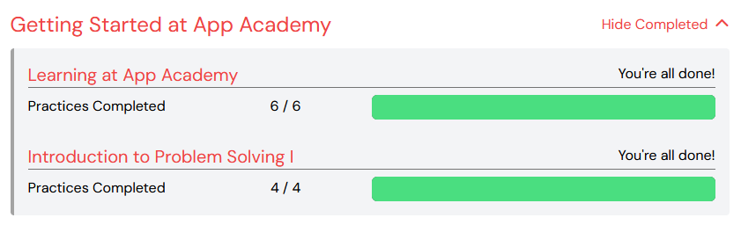
JavaScript Fundamentals | Completed 02/16/2024 | 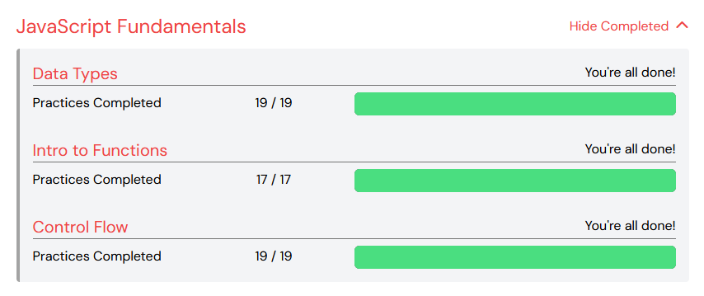
Setting Up Your Environment I | Completed 02/21/2024 | 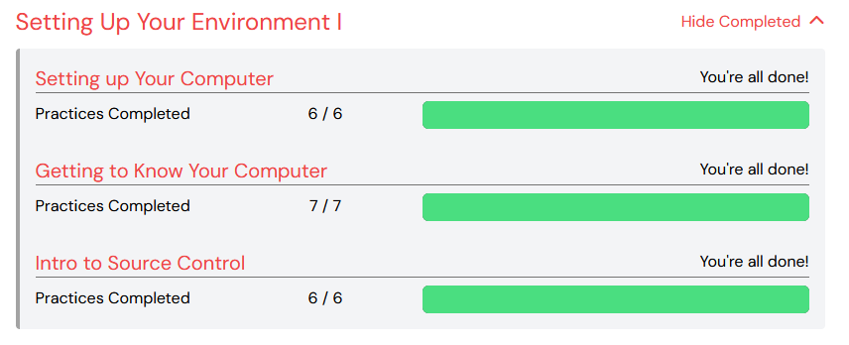
HTML & CSS Fundamentals | Completed 02/23/2024 | 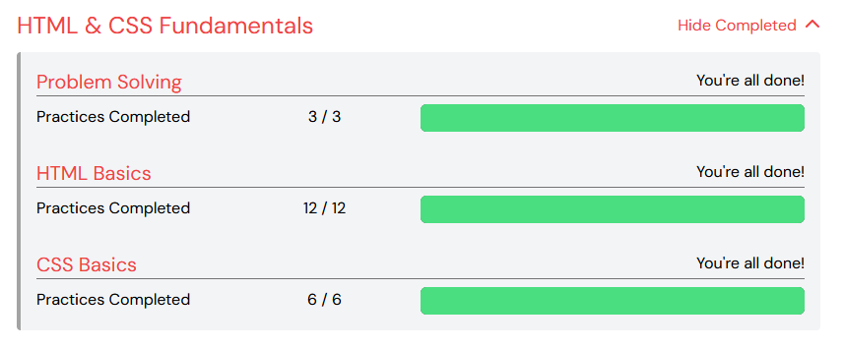
Intermediate HTML & CSS | Completed 02/29/2024 | 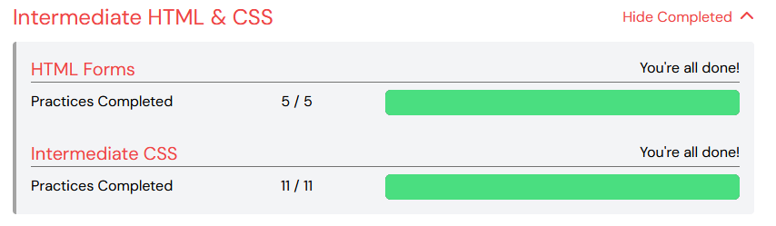
HTML & CSS: Putting it All Together | Completed 03/07/2024 | 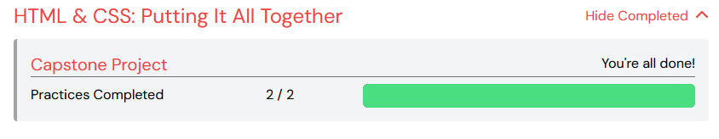
Setting Up Your Environment II | Completed 03/07/2024 | 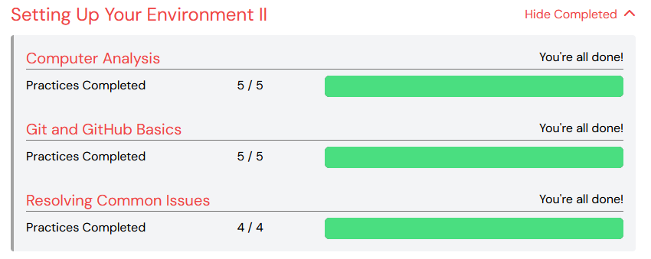
Intermediate JavaScript | Completed 03/11/2024 | 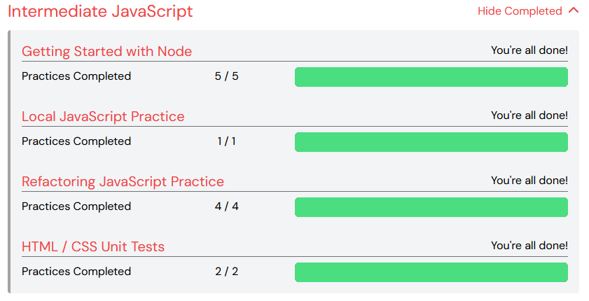

JavaScript Fundamentals

Unit | Status | Proof
Introduction to JavaScript | Completed 03/13/2024 | 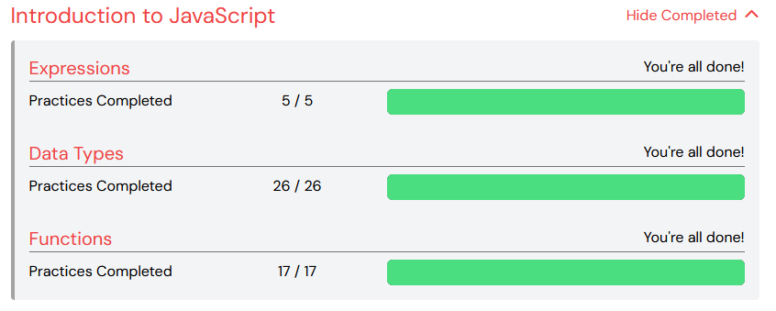
Control Flow | Completed 03/20/2024 | 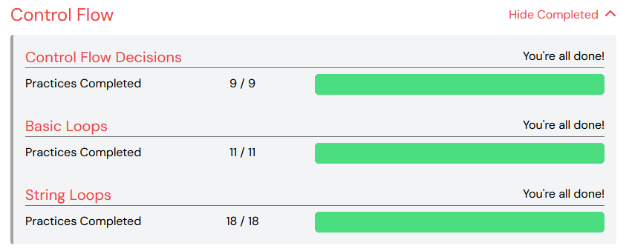
Intermediate JavaScript | Completed 03/25/2024 | 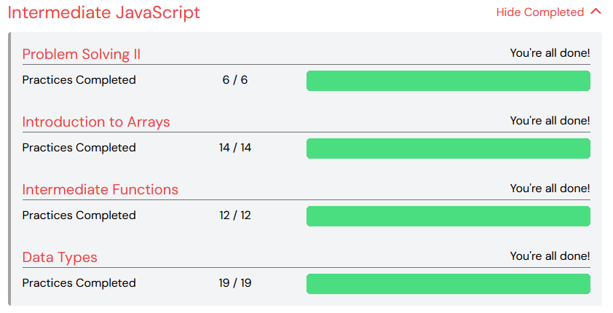
Intermediate Arrays | Completed 03/28/2024 | 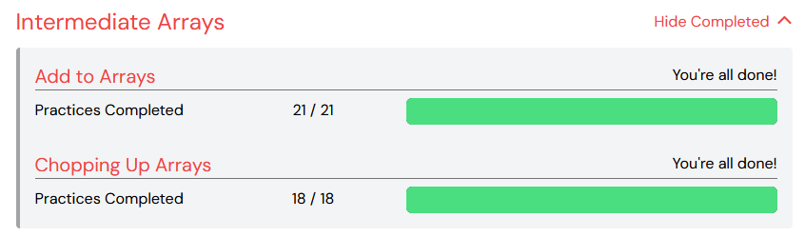
Advanced Arrays | Completed 04/01/2024 | 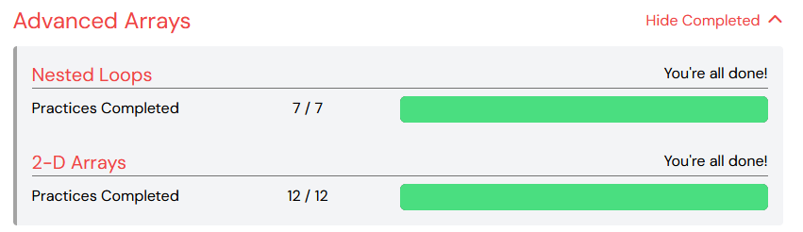
Additional Practices | Completed 04/01/2024 | 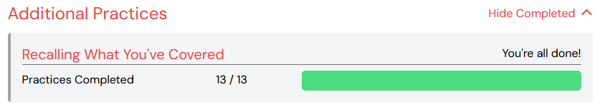
Advanced Array Methods | Completed 04/03/2024 | 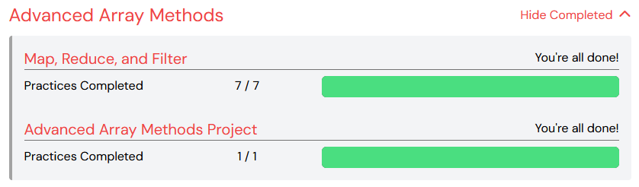

Intermediate JavaScript

Unit | Status | Proof
Local JavaScript | Completed 04/08/2024 | 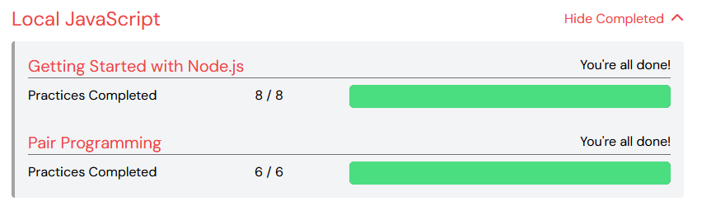
Objects | Completed 04/11/2024 | 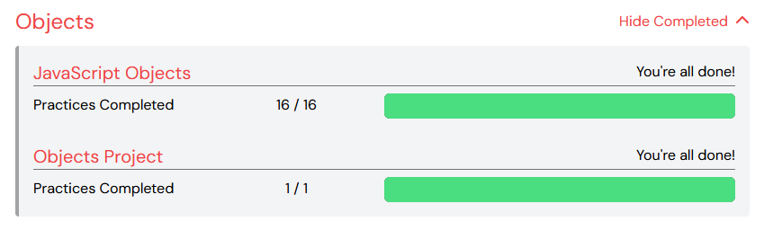
Callbacks | Completed 04/17/2024 | 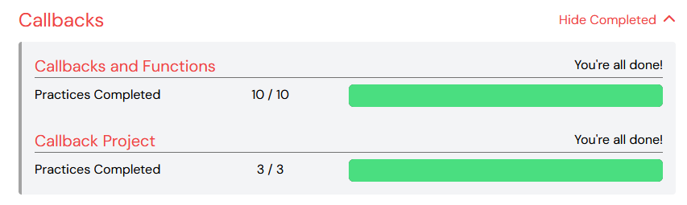
Scope and Closures | Completed 04/19/2024 | 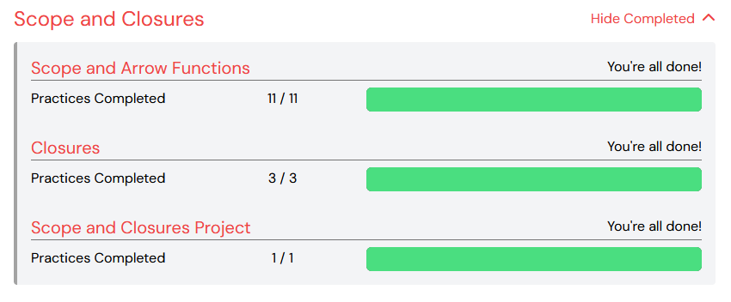
Recursion | Completed 04/25/2024 | 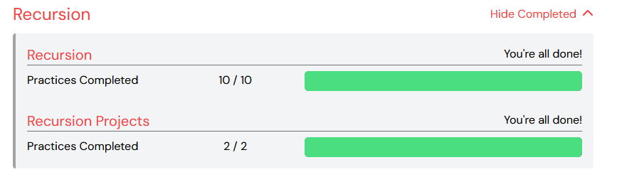
IIFEs and Recalls | Completed 04/26/2024 | 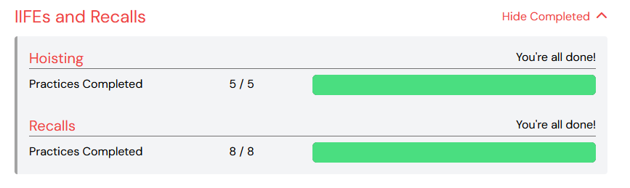
Asynchronicity | Completed 04/30/2024 | 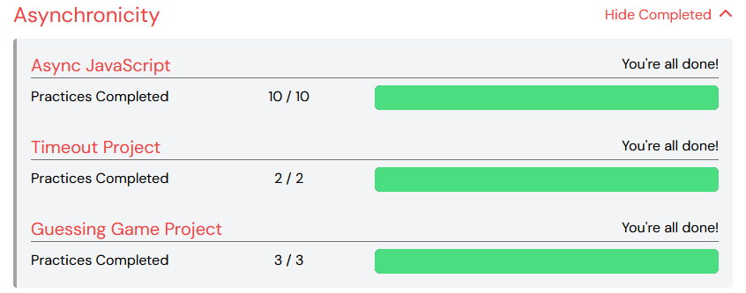
TDD and OOP
Unit | Status | Proof
Basic Coding Principles | Completed 05/03/2024 | 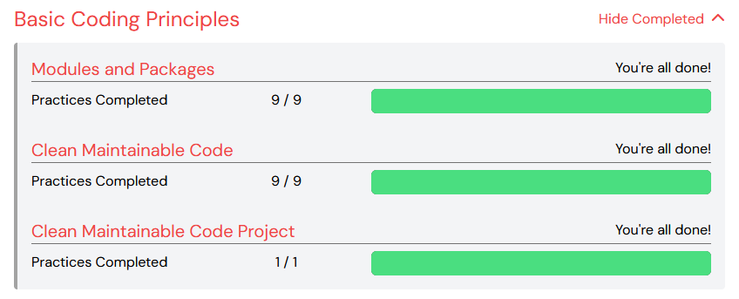
Object-Oriented Programming | Completed 05/09/2024 | 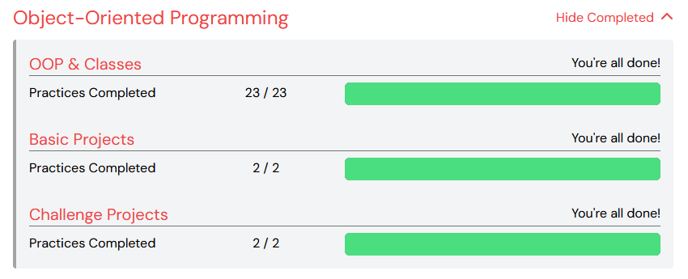
Context in JavaScript | Completed 05/17/2024 | 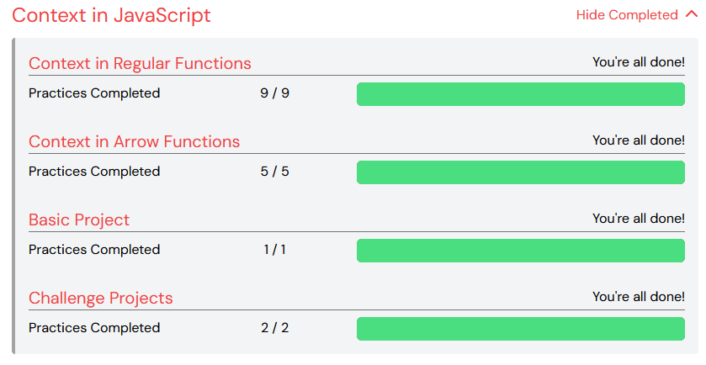
TDD Basics
Intermediate TDD

Data Structures and Algorithms

Unit | Status | Proof
Code Performance
Data Structures I
Whiteboarding I
Data Structures II
Sorting
Trees and Binary Search
Graphs
Whiteboarding II

HTML and CSS

Unit | Status | Proof
Intro to Web Design
CSS Fundamentals
Intermediate CSS
Advanced CSS
CSS Capstone Project

Servers, APIs, and Promises

Unit | Status | Proof
HTTP Servers I
HTTP Servers II
Asynchronous JavaScript
APIs
Networks

Frontend JavaScript

Unit | Status | Proof
The Browser
Working with the DOM
Handling Events and Data
Browser Storage
Capstone Project

Express and SQL

Unit | Status | Proof
Express Basics
Intermediate Express
Express Capstone
SQL Basics
Intermediate SQL
SQL Capstone
Advanced SQL Topics

Express and Sequelize

Unit | Status | Proof
Sequelize Foundations
Relationships in Sequelize
Real World Sequelize Applications
Express and SQL Capstone

Web Security and Authentication

Unit | Status | Proof
Web Application Security
Backend Authentication

React

Unit | Status | Proof
React Basics
React Hooks and Forms
React Context and Jest
Class Components

Redux and Authentication

Unit | Status | Proof
Redux Basics
Redux Thunk
Full Stack Capstone

Python

Unit | Status | Proof
Data Types
Functions and Statements
Structured Data I
Structured Data II
Object-Oriented Python
Python Environment and Testing
Python Capstone

Flask, SQLAlchemy, and Forms

Unit | Status | Proof
Flask Basics
SQLAlchemy Basics
Migrations

Docker and Microservices

Unit | Status | Proof
Docker Basics
Docker Images
Docker Compose
Microservices Applied

